MATH 107 QUIZ 4 Instructor: J. Alexander
NAME: _______________________________
I have completed this assignment myself, working independently and not consulting anyone except the instructor.

INSTRUCTIONS
- The quiz is worth 100 points. There are 13 problems. This quiz is open book and open notes. This means that you may refer to your textbook, notes, and online classroom materials, but you must work independently and may not consult anyone (and confirm this with your submission). You may take as much time as you wish, provided you turn in your quiz no later than Sunday, April 23rd.
- Show work/explanation where indicated. Answers without any work may earn little, if any, credit. You may type or write your work in your copy of the quiz, or if you prefer, create a document containing your work. Scanned work is acceptable also. In your document, be sure to include your name and the assertion of independence of work.
- General quiz tips and instructions for submitting work are posted in the Quizzes module.
- If you have any questions, please contact me by e-mail.
1. (4 pts) Solve the inequality x² ≥ 8x and write the solution set in interval notation.
(no explanation required) 1. _______
A. [8, ∞)
B. (–∞, 0] ∪ [8, ∞)
C. (–∞, 8] ∪ [0, ∞)
D. [0, 8]

2. (4 pts) Solve $\frac{x + 5}{x^{2 }- 9x+18}$≤ 0 and write the solution set in interval notation. 2. _______
(no explanation required)
A. (-5, 6)
B. (–∞, –5]
C. (–∞, –5] ∪ (3, 6)
D. [–5, 3) ∪ (6, ∞)

3. (4 pts) For f (x) = x³ – 4x² + 3x – 6, use the Intermediate Value Theorem 3. _______

to determine which interval must contain a zero of f. (no explanation required)

A. Between 0 and 1
B. Between 1 and 2
C. Between 2 and 3
D. Between 3 and 4

4. (4 pts) Translate this sentence about area into a mathematical equation.
The distance an object falls, D, is directly proportional to the square of the time of the fall, t.

5. (8 pts) Look at the graph of the quadratic function and complete the table. [No explanations required.]
Graph | Fill in the blanks | Equation
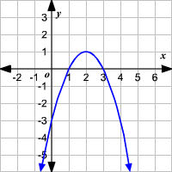 | State the vertex:  ____________  State the range:  _____________  State the interval on which the function is decreasing:  _____________ | The graph represents which of the following equations?  Choice:____  A. y = x² - 4x - 3  B. y = –x² + 4x - 3  C. y = 2x² - 3x – 2  D. y = -x² + x + 3

6. (6 pts) Each graph below represents a polynomial function. Complete the following table.
(no explanation required)
Graph | 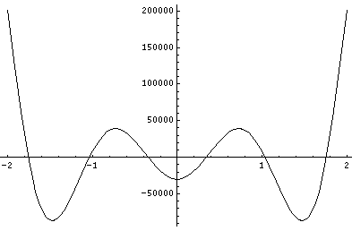  Graph A | 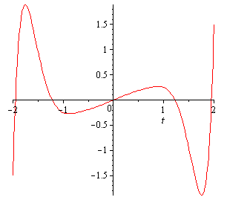  Graph B
Is the degree of the polynomial odd or even? (choose one)
Is the leading coefficient of the polynomial positive or negative? (choose one)
How many real number zeros are there?
7. (15 pts) Let $P\left(x\right)=x^{3}+2x^{2}-5x-6$ When factored, $P\left(x\right)=\left(x+1\right)\left(x-2\right)\left(x+3\right)$

(a) State the domain.

(b) Which sketch illustrates the end behavior of the polynomial function?
A.  vvvv | B.  vvvv | C.  vvvv | D.  vvvv

Answer: ________

(c) State the y-intercept:

(d) State the real zeros:

(e) Sketch the graph of P(x) below (graph must include real zeros and y-intercept)

.

8. (8 pts) Let . (no explanations required)

(a) State the y-intercept.

(b) State the x-intercept(s).

(c) State the vertical asymptote(s).

(d) State the horizontal asymptote.

9. (8 pts) Solve the equation. Check all proposed solutions. Show work in solving and in checking, and state your final conclusion.

10. (8 pts) Which of the following functions is represented by the graph shown below? Explain your answer choice. Be sure to take the asymptotes into account in your explanation.

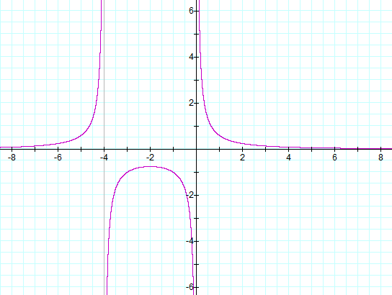
10. _____
A. $f\left(x\right)= \frac{x^{2} }{x^{2}- 16}$

B. $f\left(x\right)= \frac{3}{x^{2}- 16}$

C. $f\left(x\right)= \frac{x }{x^{2}- 4x}$

D. $f\left(x\right)= \frac{3}{x^{2}+ 4x}$

11. (8 pts) For z = 3 − 2i and w = 4 + i, find z/w. That is, determine $\frac{3 - 2i}{4+ i}$ and simplify as much as possible, writing the result in the form a + bi, where a and b are real numbers. Show work.

12. (8 pts) Consider the equation x² + 12 = -6x. Find the complex solutions (real and non-real) of the equation, and simplify as much as possible. Show work.

13. (15 pts)
The cost, in dollars, for a company to produce x widgets is given by C(x) = 5250 + 7.00x for
x ≥ 0, and the price-demand function, in dollars per widget, is p(x) = 45 − 0.02x for 0 ≤ x ≤ 2250.

In Quiz 2, problem #10, we saw that the profit function for this scenario is
P(x) = − 0.02x² + 38.00x − 5250.

(a) The profit function is a quadratic function and so its graph is a parabola.

Does the parabola open up or down? __________

(b) Find the vertex of the profit function P(x) using algebra. Show algebraic work.

(c) State the maximum profit and the number of widgets which yield that maximum profit:

The maximum profit is _______________ when ____________ widgets are produced and sold.

